Cyclomatic Complexity

Cyclomatic complexity of a code section is the quantitative measure of the number of linearly independent paths in it. It is a software metric used to indicate the complexity of a program. It is computed using the Control Flow Graph of the program. The nodes in the graph indicate the smallest group of commands of a program, and a directed edge in it connects the two nodes i.e. if second command might immediately follow the first command.

For example, if source code contains no control flow statement then its cyclomatic complexity will be 1 and source code contains a single path in it. Similarly, if the source code contains one **if condition** then cyclomatic complexity will be 2 because there will be two paths one for true and the other for false.

Mathematically, for a structured program, the directed graph inside control flow is the edge joining two basic blocks of the program as control may pass from first to second.  
So, cyclomatic complexity M would be defined as,

***M = E – N + 2***

*where,  
E = the number of edges in the control flow graph  
N = the number of nodes in the control flow graph*

Steps that should be followed in calculating cyclomatic complexity and test case design are:

* Construction of control flow graph with nodes and edges from code.
* Identification of independent paths.
* Cyclomatic Complexity Calculation
* Design of Test Cases

Consider the following code:

A = 10

IF B > C THEN

A = B

ELSE

A = C

ENDIF

Print A

Print B

Print C

**Control Flow Graph** of above code

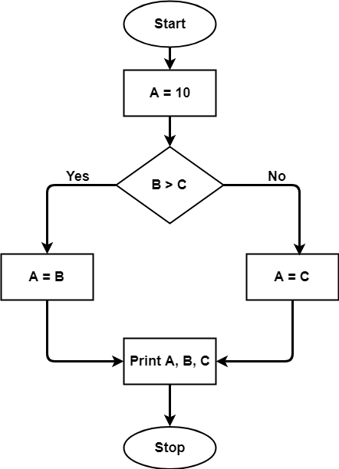

The cyclomatic complexity calculated for the above code will be from the control flow graph. The graph shows seven shapes(nodes), seven lines(edges), hence cyclomatic complexity is 7-7+2 = 2.

**Use of Cyclomatic Complexity:**

* Determining the independent execution paths proves to be very helpful for Developers and Testers.
* It can make sure that every path has been tested at least once.
* Thus helps to focus more on uncovered paths.
* Code coverage can be improved.
* Risk associated with the program can be evaluated.